RNN (Recurrent Neural Network)

- RNN is a neural network designed for sequential data, it remembers previous information while processing current input.
- RNN is a neural network that handles sequential data by maintaining memory of previous inputs.
- RNN is a neural network that processes data step-by-step and uses past information to make current decisions.
- RNN reads text word by word and remembers previous words to understand the meaning of the sentence.

💡 Key idea:
Current output depends on current input + past memory

Why RNN is needed?
Some data has order and sequence, for example:
- Sentences in NLP
- Time-series data
- Speech signals
- Normal ANN treats all inputs independently
- RNN keeps memory of past inputs

How RNN works (simple idea)
At each step, RNN takes:
- Current input
- Previous memory (hidden state)
and produces:
- New memory
- Output

Mathematically:
hₜ = f(xₜ + hₜ₋₁)

Example:
Sentence: “I love AI”
RNN reads:
- “I” → stores meaning
- “love” → understands emotion using previous word
- “AI” → final understanding
So RNN understands the sentence in context, not word-by-word separately.

Where RNN is used?
- Sentiment Analysis
- Language Translation
- Speech Recognition
- Time-series Forecasting

Limitation of RNN
- Cannot remember long sentences properly
- Suffers from Vanishing Gradient Problem
That’s why we use LSTM and GRU

How RNN works in NLP

Example sentence:
“I love NLP”

Step 1: Text → Numbers
Words are converted into vectors using:
- One-Hot Encoding
- Word Embeddings (Word2Vec, GloVe)
Example:
I → x₁
love → x₂
NLP → x₃

Step 2: Sequential Processing
RNN processes one word at a time
h₁ = f(x₁, h₀)
h₂ = f(x₂, h₁)
h₃ = f(x₃, h₂)
Where:
- xₜ = current word vector
- hₜ = hidden state (memory)
- h₀ = initial memory (usually zeros)
📌 Hidden state carries context forward.

Step 3: Output
Based on task:
- Next word prediction
- Sentiment (positive/negative)
- Tagging (noun, verb, etc.)

Why NLP needs RNN?
- NLP (Natural Language Processing) works with text & language, which is sequential data.
👉 Example sentence:
“I love deep learning”
Order matters:
- “Love I deep learning” (meaning changes)
- “I love deep learning”
❗ Traditional ANN treats inputs independently
❗ NLP needs memory of previous words
RNN (Recurrent Neural Network) solves this.

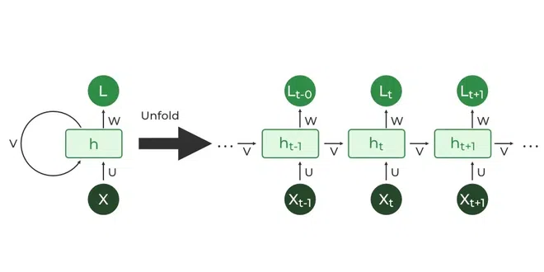
RNN Architecture

x₁ → [RNN] → h₁ → y₁
↓
x₂ → [RNN] → h₂ → y₂
↓
x₃ → [RNN] → h₃ → y₃
- Same RNN cell reused
- Memory flows through time

NLP Tasks using RNN

🔹 1. Sentiment Analysis
Sentence:
“Movie was very good”
RNN remembers:
- “very” affects “good”
- Final output = Positive

🔹 2. Language Modeling
Predict next word:
“I am learning ___”
RNN predicts:
- “NLP”
- “Python”
- “Deep”

🔹 3. POS Tagging
“I eat rice”
RNN assigns:
- I → Pronoun
- eat → Verb
- rice → Noun

🔹 4. Named Entity Recognition (NER)
“Ganesh works at Google”
- Ganesh → Person
- Google → Organization

Why simple RNN has problems?

Vanishing Gradient Problem
- Long sentences → RNN forgets early words
Example:
“I watched this movie last year and I didn’t like it”
RNN may forget “didn’t”
Solution: LSTM & GRU
To improve NLP performance, we use:

✅ LSTM (Long Short-Term Memory)
- Has gates:
  - Forget gate
  - Input gate
  - Output gate
- Remembers long-term dependencies

✅ GRU
- Simpler than LSTM
- Faster training
Most NLP systems use LSTM / GRU instead of plain RNN

When to use RNN in NLP?
Task | Use RNN?
Small dataset | ✅
Sequence understanding | ✅
Long text | ❌ (use LSTM/Transformer)
Real-time sequence | ✅

